**Installing Python Environment**

There are a few steps to take before jumping into Python. We have to make the environment ready for our python programming:

1. Installing python itself from [Python Website](https://www.python.org/).
   1. You can hover your mouse over download button in the main page of python and by clicking on python 3.7.4, you can download it. (It may be a different version at the time you are checking this tutorial.)
   2. After the file was downloaded, the installation is just an easy next-next process.
   3. At this step, you should check the “Add Python to environment” box as you see in the image:

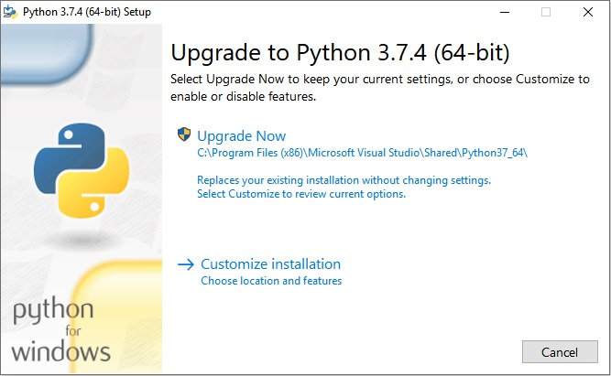

1. Installing Anaconda from [Anaconda Website](https://www.anaconda.com/download/). (This is an alternative for Python installation from source)
   1. You can see the link in the anaconda website. Just click it and wait for a few minutes.
   2. After it being downloaded, it has a very easy installation process like all of the other software.
2. After Anaconda was being installed, go to your windows search and search for: “Anaconda Prompt”.

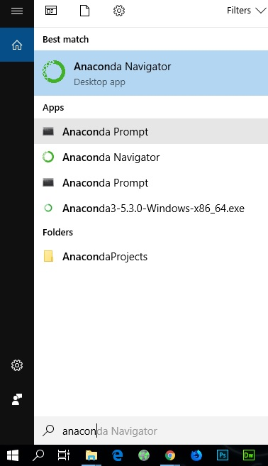

* 1. You should then enter the following commands in that terminal, so it can install all the packages we will use in following sections:
     1. conda install numpy
     2. conda install pandas
     3. conda install matplotlib
     4. conda install scipy

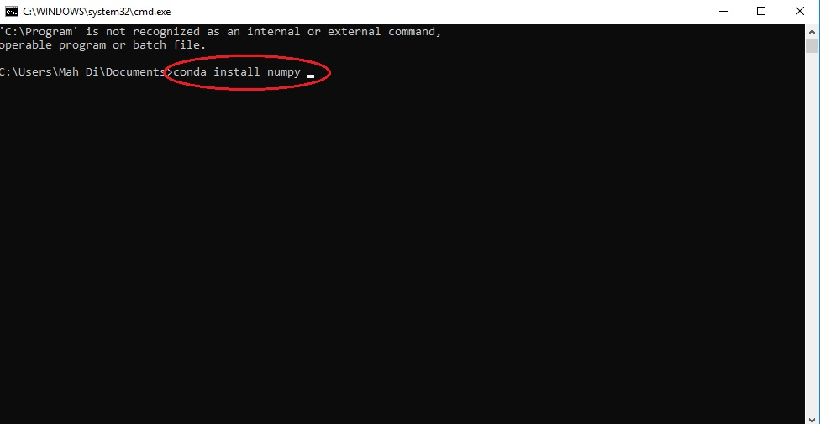

* 1. After entering each of these commands, Anaconda is going to download and install the packages from the relevant server.

1. The good news is that, the “Jupyter Notebook” (ipython Notebook) that we talked about it earlier, is coming with Anaconda. So we don’t have to take any further steps to install that.

Congrats! You’ve done with the environment and ready to get into Python’s world.

Question? [Contact me pls](https://www.linkedin.com/in/mahdirahbar/)